**EE175AB Final Report Template**

**Project Title**

**EE 175AB Final Report**

**Department of Electrical Engineering, UC Riverside**

|  |  |
| --- | --- |
| Project Team Member(s) |  |
| Date Submitted |  |
| Section  Professor |  |
| Revision | e.g., revision 2.1 |
| URL of Project Wiki/Webpage | http:// |
| Permanent Emails of all team members |  |

Summary

This report presents …….

**Note:**

* **Sections marked with * are required**
* **In each section, you must clearly identify which team member is responsible for which objectives, modules or tasks.**

Revisions

| Version | Description of Version | Author(s) | Date Completed | Approval |
| --- | --- | --- | --- | --- |
| Version Number | Information about the revision. This table does not need to be filled in whenever a document is touched, only when the version is being upgraded. | Full Name | 00/00/00 |  |
| 0.5 | First draft | X,y,z | 01/01/2005 |  |
| 0.8 | List major changes from previous version, reference to the related Engineering Change Notices (ECN) or Engineering Design Notes (EDN). | X,y,z | 02/01/2005 |  |

**This template serves as a basis for the EE175 Senior Design Project Final Report.**

**This document should be customized to the needs of each specific project. This template is only a starting point.**

**This template does not imply that all components listed in this template should be included (except the sections marked with *) nor does it imply that this template includes all the necessary components needed for a specific project. Instead this template provides a basic starting point that will work well in many situations. The design team must modify and/or expand the contents in order to meet the specific requirements of their project.**

**REMOVE the sections (without *) that do not apply to your project and renumber the sections**

**You can change the section titles to better match your project.**

Table of Contents

Revisions 2

Table of Contents 4

1. * Executive Summary 7
2. * Introduction 8
   1. * Design Objectives and System Overview 8
   2. * Backgrounds and Prior Art 8
   3. * Development Environment and Tools 8
   4. * Related Documents and Supporting Materials 8
   5. * Definitions and Acronyms 8
3. * Design Considerations 9
   1. * Realistic Constraints 9
   2. System Environment and External Interfaces 9
   3. * Industry Standards 9
   4. * Knowledge and Skills 9
   5. * Budget and Cost Analysis 9
   6. * Safety 9
   7. Performance, Security, Quality, Reliability, Aesthetics etc. 10
   8. * Documentation 10
   9. Risks and Volatile Areas 10
4. * Experiment Design and Feasibility Study 11
   1. Experiment Design 11
   2. Experiment Results, Data Analysis and Feasibility 11
   3. Experiment Design 11
   4. Experiment Results, Data Analysis and Feasibility 11
   5. Experiment Design 12
   6. Experiment Results, Data Analysis and Feasibility 12
5. * Architecture and High Level Design 14
   1. * System Architecture and Design 14

Main System Overview 14

* 1. * Hardware Architecture 19
  2. * Software Architecture 19
  3. * Rationale and Alternatives 19

1. Data Structures (include if used) 20
   1. Internal software data structure 21
   2. Global data structure 21
   3. Temporary data structure 21
   4. Database descriptions 21
2. * Low Level Design 22
   1. Module 1: Controller 22
      1. Controller interface description 23
   2. Module 2: MCU 1 23
      1. Processing narrative for MCU 1 24
      2. MCU 1 interface description 24
      3. MCU 1 processing details 24
   3. Module 3: Bluetooth 25
      1. Bluetooth interface description 26
      2. Bluetooth module complications 26
   4. Module 4: MCU 2 27
      1. Processing narrative for MCU 2 28
      2. MCU 2 interface description (change italics to the name of your module) 28
      3. MCU 2processing details (change italics to the name of your module) 28
3. * Technical Problem Solving 31
   1. * The X Problem (change X to a description of your problem, e.g., Bluetooth Interface Problem, the Line Following Problem) 31
   2. * Solving the X Problem (change X to a description of your problem, e.g., Bluetooth Interface Problem) 31
4. User Interface Design 32
   1. Application Control 32
   2. User Interface Screens 32
5. * Test Plan 33
   1. Manual Control Test Design 33
   2. Bug Tracking 33
   3. Quality Control 33
   4. Identification of critical components 33
   5. Items Not Tested by the Experiments 34
   6. Three Directional Motor Movement Test Design 34
   7. Bug Tracking 34
   8. Quality Control 34
   9. Identification of critical components 35
   10. Items Not Tested by the Experiments 35
6. * Test Report 36
   1. * Test 1 36
   2. * Test i (one section for each test i = 2, …., n) 36
7. * Conclusion and Future Work 37
   1. * Conclusion 37
   2. Future Work 37
   3. * Acknowledgement 37
8. * References 38
9. * Appendices 39

# * Executive Summary

In one page, present the summary of your project. Outline the motivation, overall goals, design objectives, key features, testing results, and your important achievements.

You want to convince the readers succinctly that your project is important, useful, makes a good senior design project and you succeed in achieving your design objectives.

You may use several paragraphs, but no more sub-sections.

# * Introduction

This space may be used to provide an introduction for the design and ties to other project materials.

## * Design Objectives and System Overview

Describe the concept and application of the design: What are you designing, technical principles, why this is a meaningful project, what are the intended applications, how is it related to subjects in electrical engineering, what are the overall goals of the project.

High-level description of the system structure, functionalities, interactions with external systems, system issues, operating environment, user environment, inputs, outputs, etc. You do not need to provide implementation details in this section.

You must provide a list of quantitative technical design objectives, e.g., accuracy of 95%, sensor range of 20 feet, 90% successful retrieval or recognition, mean square error < 0.1, response time < 1ms, dynamic range of 20Vp-p, bandwidth of 20MHz, transmission range>100m at 100mW, SNR>10dB, data transfer rate = 100Mbps, costing less than $500, etc.

Responsibilities: clearly state which team member is responsible for which goals/objectives

## * Backgrounds and Prior Art

Perform literature and Internet search to find out existing products or designs for achieving the same or similar objectives of your design. Describe your findings here. List all references in the References section (Section 14). What are the advantages and shortcomings of what you want to design compared to existing products and designs?

## * Development Environment and Tools

Describe the design environment, hardware and software tools, and testing equipment required to complete this project. Example, your hardware development environment is Rasberry pi with Linux, you used Android Studio for your app development, etc.

## * Related Documents and Supporting Materials

References to any industry standards involved in your project should be listed here.

(Optional) – Note any other references or related materials. For instance, if this design required interfacing with X10 hardware devices, then you would want a reference to the X10 specification. If you use the .NET development environment or need to interface with MS Internet Explorer, the related documents should be referenced here.

## * Definitions and Acronyms

List any project definitions and acronyms introduced to the project by this design.

# * Design Considerations

This section describes issues that need to be addressed or resolved prior to or while completing the design as well as issues that may influence the design process.

## * Realistic Constraints

Describe any constraints on the system that have a significant impact on the design of the system. (e.g. power consumption constraints, voltage/current supply constraints, processor speed/memory size constraints, frequency constraints, motor speed constraints, wireless transmission power and range constraints, performance requirements, constraints from application requirements, end user characteristics, weight/size constraints, validation requirements, project time and budget constraints, government regulations and legal constraints, societal and environmental constraints, requirements of industry standards, end product price constraints, etc.)

## System Environment and External Interfaces

Describe the system, hardware and software that your product must operate in and interact with, any communication protocols and APIs the system must comply to, etc.

## * Industry Standards

Describe the industry standards involved with the hardware and software in your design. This may include hardware, software and protocols, such as RS232, I2C, USB, PCI, IEEE802.11, Bluetooth, Zigbee, RFID, UAL, safety standards, etc. Also discuss de facto standards such as operating system APIs, device drivers, programming language/environments, popular interfaces such as SPI, etc. used in your project.

You must reference the standards documents and describe how you design will comply with the standards.

You must describe how the standard requirements affected your design and include examples of aspects of the standards that you encountered in your design projects, e.g., voltage levels, packet size, baud rate, data rate, carrier frequency, etc.

## * Knowledge and Skills

Describe the knowledge and skills required by this project. Complete the following for each team member:

List all the Electrical Engineering and other technical courses (e.g., Computer science or upper division physics) you took or are taking that are related to your project.

List any new knowledge and skills that you had to learn while working on the project in order to complete it.

## * Budget and Cost Analysis

Present your budget and/or cost analysis.

## * Safety

Discuss safety considerations and specify safety objectives

## Performance, Security, Quality, Reliability, Aesthetics etc.

Describe the considerations and processes to ensure meeting performance, security, quality control, reliability, aesthetics etc. requirements.

## * Documentation

Describe the processes for generating and maintaining technical and user documentation for the project, including design notes, engineering change notices, version update and version control procedures.

## Risks and Volatile Areas

(Optional) - Describe any notably volatile or risky areas of the system and any special strategies taken to mitigate risks or prepare for changes. These are risks specific for the design—not project management type stuff. For instance if there is an algorithm that is especially difficult that you must implement.

# * Experiment Design and Feasibility Study

## Experiment Design

Test movement capability for the Y axis with one smooth and one threaded bar. Chris assembled both the left and right Y axis and use a connected piece of metal to see if it properly slides the linear motion glider forward and backward. Dineth will control the motor’s direction while Steven takes notes on what he observes. If needed, Chris can assist the machine in case of aa malfunction. The expected result is that the Y threaded bar will gracefully move the bar across the Y axis on both ends.

## Experiment Results, Data Analysis and Feasibility

In the experiment we found that 4/10 trial runs were unsuccessful. This means that a new design for the Y axis will have to be implemented. We need a stronger movement on one end right side of the Y-axis because the platform has to move precisely. Chris will design a new way to move the Y axis platforms at an even speed using belts to attach the two sides together.

## Experiment Design

Calculate the total print area size. Chris assembled the X and Y axis, Dineth wrote the code for the end stops, and Steven will document results. Chris will set the board in the starting position at the origin (0,0) (bottom left when facing the front of the board). The once the machine is powered on, Chris will let the machine run as far upwards and as far to the right as possible. The expected results will be the total machine code executions for the print area to be crossed.

## Experiment Results, Data Analysis and Feasibility

On average our total X and Y axis code execution area is 9103x9915. Which is equivalent to our 273x297 mm physical X and Y axis area. We nullified one test due to the number values being far our of the average likely due to an error with an end stop. With this our maximum print size is very high detail so printing HD pictures is not out of the scope of our project. We can use the large print area to have enough room to manipulate the wood pieces that we will be burning.

## Experiment Design

This experiment will test timing various delay amounts for the speed of our motors movement. Chris will time the cross platform distance, Steven will use the joystick and thus control the platform, and Dineth will document the results. Chris will set the board in the starting position at the origin (0,0) (bottom left when facing the board). The once the machine is powered on, Steven will let the machine run as far upwards and as far to the right as possible. After timing how long it takes the printer to go from (0,0) to (9103,9915) at varying speed we will know our range for delay amount and thus our speed for different shades of our drawings

## Experiment Results, Data Analysis and Feasibility

Carry out the experiments designed above and present experimental data,

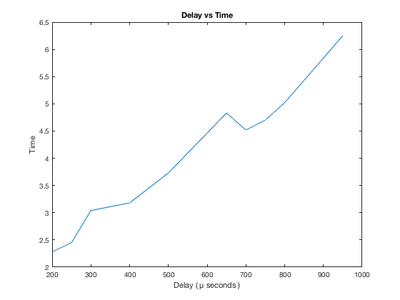

| **Delay** | **Time to cross board** |
| --- | --- |
| **200** | 2.2800 |
| **250** | 2.4500 |
| **300** | 3.0400 |
| **400** | 3.1800 |
| **500** | 3.7300 |
| **650** | 4.8300 |
| **700** | 4.5200 |
| **750** | 4.7000 |
| **800** | 5.0200 |
| **950** | 6.2500 |

We found that having the delay < 200 or >950 microseconds would cause stability issues and cause the motors to skip teeth and sound terrible. Steven decided that our usable range would be within the safety of 300-800 microseconds for our various shades. This would mean 300 microseconds would be our lightest shade, 500 our medium shade, and 800 as the darkest shade possible. With this data we decided we will be able to print on our machine in different shades.

# * Architecture and High Level Design

*Using the digital model since its easier to isolate physical components*

## * System Architecture and Design

## Main System Overview

Figure 5.1.1

Figure 5.1.1 shows full system view of the digital model of the X, Y, and Z axis mounted on the wood structure.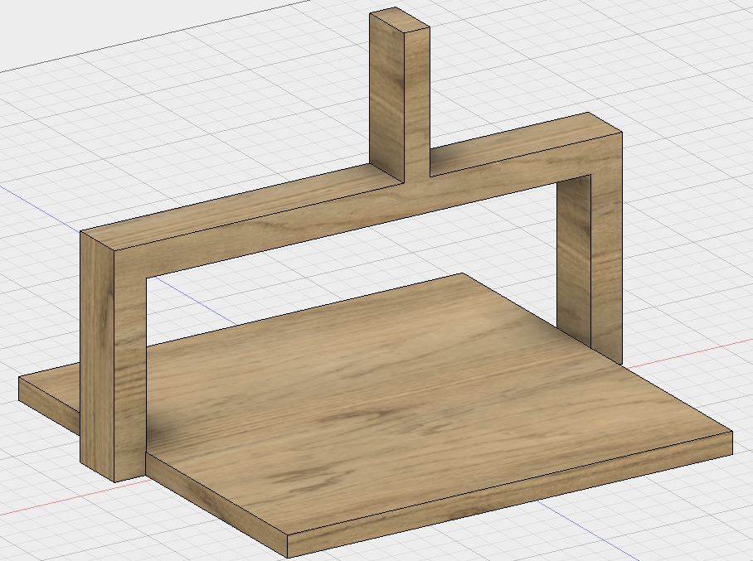

Wood structure composed of a base piece of ply wood and 3 2x4s creating an upside down y shape. This y shape will be used to mount our Z axis system

Figure 5.1.2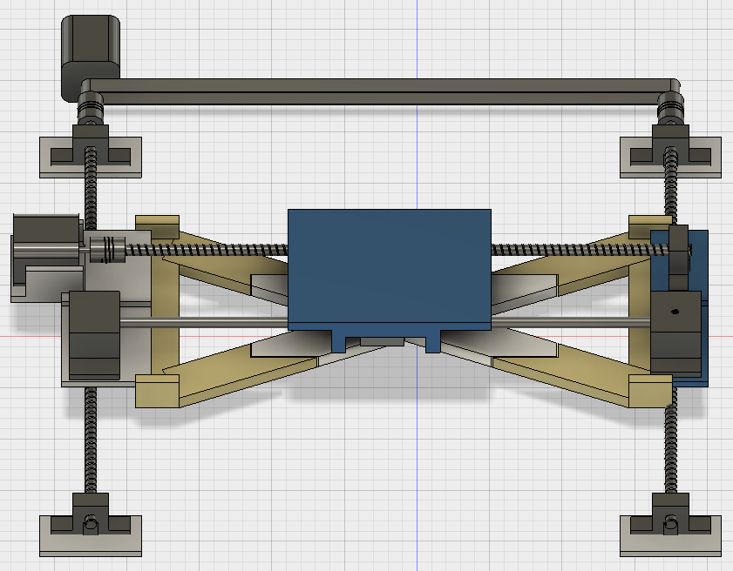

Figure 5.1.3 shows the X and Y axis systems isolated from the system.

Figure 5.1.3 (Above) Figure 5.1.4 (Below)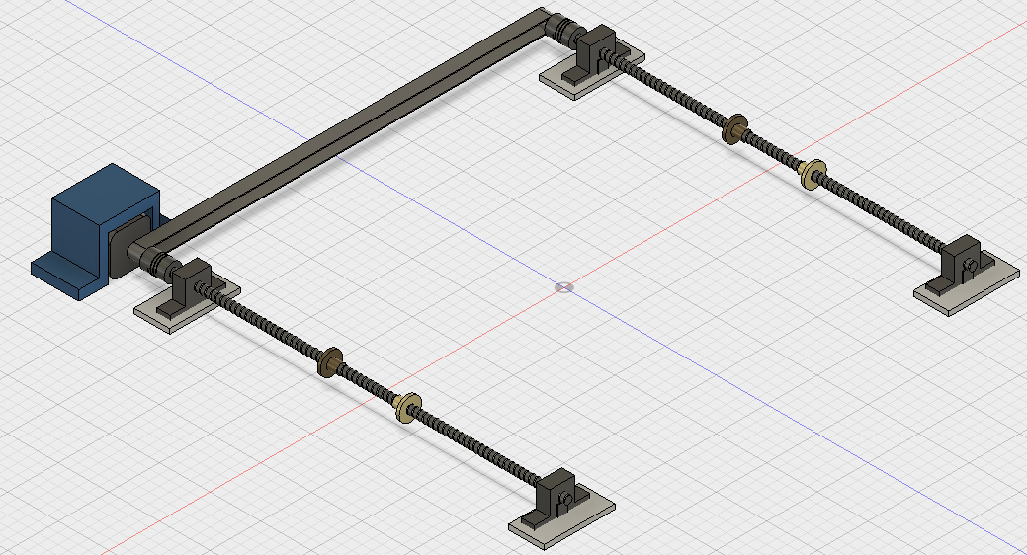

Figure 5.1.4 shows the isolated y axis system using two threaded bars, a stepper motor, and a belt to turn both bars simultaneously

Chris implemented a belt system in the back to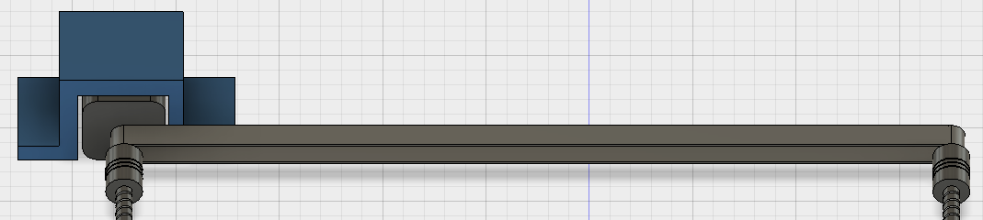 control both sides of the Y axis (Figure 5.1.5). This was done to prevent a flaw with one side lagging in movement.

Figure 5.1.5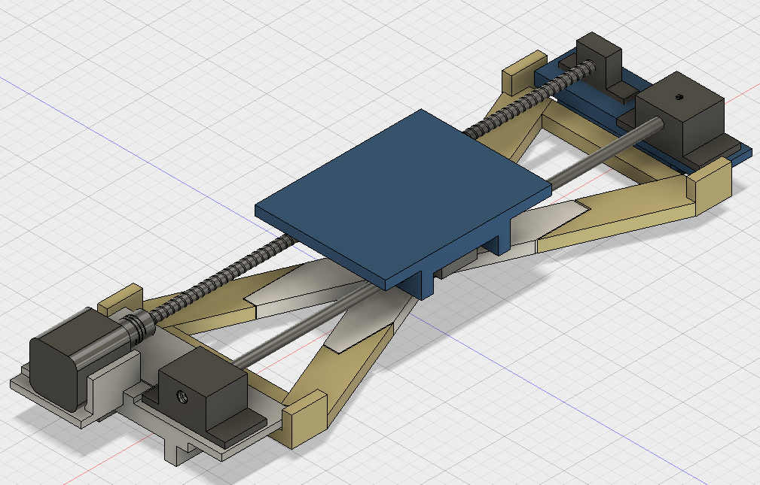

Figure 5.1.6 shows the isolated X axis. This was mounted onto the Y axis using two platforms to hold the brackets and motor.

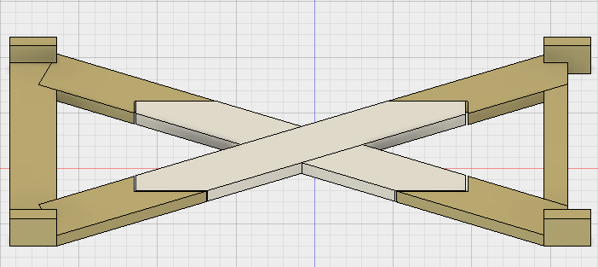Figure 5.1.6

Steven thought of adding a brace for added X axis support to help prevent lagging and allow for a stronger platform. Chris modeled, printed, and built this X brace for our X axis. (Figure 5.1.7)

Figure 5.1.7

The Z axis was the most difficult to build structurally. Using a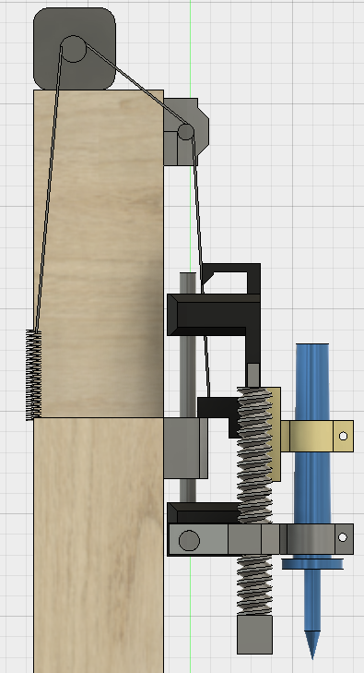 stepper motor, belt system, spring, and linear motion bars we were able to construct an operational Z axis. (Figures 5.1.8) Figure 5.1.9 shows the z axis mechanisms without the wood structure and from the front.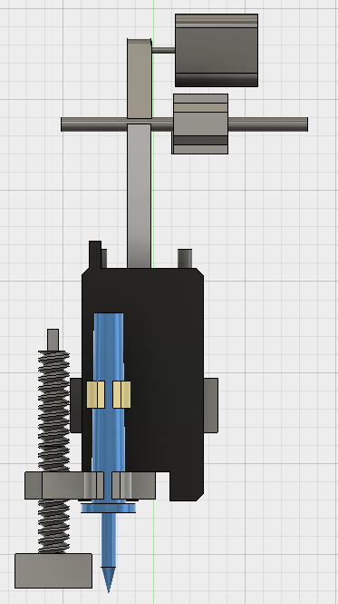

Figure 5.1.8 (Left) Figure 5.1.9 (Right)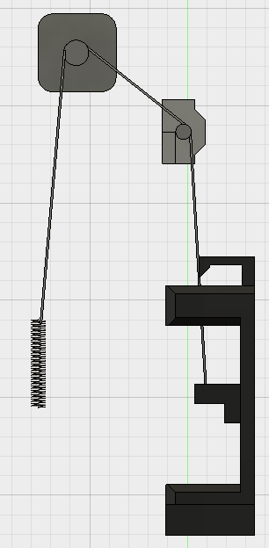

The isolated belt system shown here uses a spring attached to the wood frame to counter balance the heavy weight of the z axis components. This was one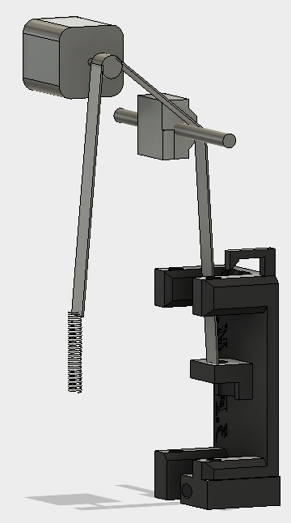

of the hardest design hurdles structurally since we originally didn't account for the weight of the Z axis to be a design problem. Chris hypothesized and built a demo pulley system initially. After success with the pulley system Chris measured the weight and assembled a spring based pulley system

Figure 5.1.10 (Left) Figure 5.1.11 (Right)

The Z axis (Figure 5.1.12) uses linear motion guides to move freely up and down. The large screw on the right side of Figure 5.1.12 is used for height calibration so that the system understands the distance to the wood for the pen. Once calibration is complete the user then moves the screw out of the way.

Figure 5.1.12

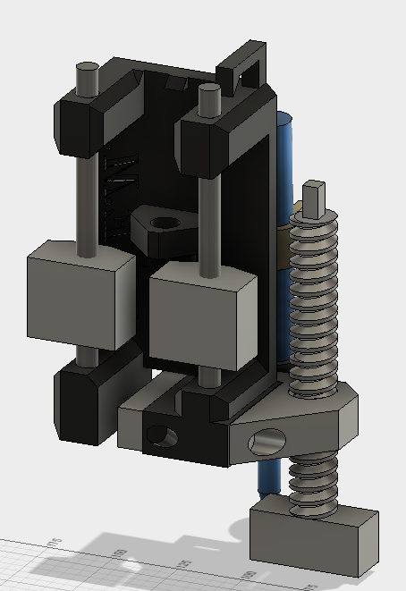

This section provides a high level overview of the structural

and functional decomposition of the system.

Focus on how and why the system is decomposed in a particular way

rather than on details of the particular components.

Include information on the major responsibilities

and roles the system (or portions thereof) must play.

A block diagram representation of the architecture must be included,

which should show the hierarchical structure of the modules;

interaction and interface among modules and with databases,

external software,

system,

and networks

Provide a description and block diagrams of a system element or set of elements at a conceptual or functional level that describes a clearly defined view or model of the entire system or a subset of the system. Each component represents a similar grouping of functionality.

State clearly who is responsible for which module/task

## * Hardware Architecture

## * Software Architecture

## * Rationale and Alternatives

This section discusses why you are using the architecture or approach you have decided upon. A discussion of other architectures or approaches considered should be presented here.

# Data Structures (include if used)

A description of all data structures including internal, global, and temporary data structures. State clearly who is responsible for which module/task

## Internal software data structure

Data structures that are passed among components the software are described.

## Global data structure

Data structured that are available to major portions of the architecture are described.

## Temporary data structure

Files created for interim use are described.

## Database descriptions

Database(s) created as part of the application is(are) described.

# * Low Level Design

This section provides low-level design descriptions that directly support construction of modules. Normally this section may be split into separate documents for different areas of the design. For each component we now need to break it down into its fundamental units or modules. Each module or block may be hardware or software or a subsystem implemented using hardware and software. Make sure to provide a well-commented schematic of all modules and/or system blocks described in the system block diagram (SBD).

Must include hardware circuit schematics and program flowchart for each module.

Example of circuit schematics: http://www.arduino.cc/en/uploads/Main/arduino-uno-schematic.pdf

Example of flowcharts of your programs: http://www.mdpi.com/electronics/electronics-03-00636/article_deploy/html/images/electronics-03-00636-g011-1024.png

## Module 1: Controller

The controller is used for user input. It has a joystick with a dual axis varied input as well as two buttons for z axis movement and menu confirmations. Steven created the original controller circuit and Chris modified the final controller circuit design for a user friendly compact design.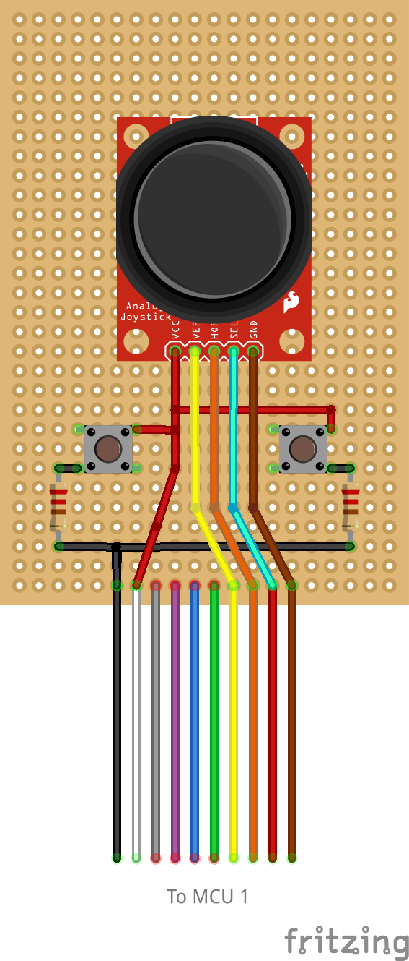

Figure 7.1.1

### Controller interface description

User input is received through a 2 axis potentiometer joystick direction and/or a button press. This links into MCU1 (Section 7.2) by sending a varied voltage value from the joystick, and the digital state of the buttons.

## Module 2*:* MCU 1

Performs the control of the system for the motors, endstops, controller, and bluetooth. This module is the core for the image and user input processing. MCU 1 was modified with a RAMPS 1.4 motor driver shield attachment and the motor drivers for the stepper motor control. MCU 1 uses Arduino’s custom C language and was used to handle the physical motion of the machines components. The motors and X and Y endstops were connected and coded by Dineth. Steven attached and coded the original controller circuit and bluetooth. Chris implemented the Z axis endstops and the high level coding for automation and integration of connected systems and modules. Pin outs are listed in section 7.2.2 for MCU 1 rather than labeled due to the RAMPs 1.4 changing port locations and having a cluttered diagram. Figure 7.2.1 is the Arduino Mega Schematic and Figure 7.2.2 is the RAMPs 1.4 motor shield schematic. 

Figure 7.2.1

Figure 7.2.2

### Processing narrative for MCU 1

MCU 1 performs in a procedural pattern based on the machines state. The processing flow is shown in section 5.3. This is shown that the machine will calibrate, then confirm user input, draw if a processed image is received, or enter a manual control mode if no image is uploaded.

### MCU 1 interface description

The input is received from both the controller module, the bluetooth module, and MCU 2. The module outputs to MCU 2 and the motor driver system.

Pin outs:

### MCU 1 processing details

MCU 1 has the motor driver shield and 3 motor drivers included within its module. These are used to provide power and accurate control of the stepper motors. The algorithm for automated control implemented in MCU 1 is based on a step per direction array that Matlab computes. This array contains values that represent how many code executions in any given direction per move. For example a section with values …, 1, 0, 0, 1,…. would make the machine move up and to the right for one code execution and …, 0, 13, 25, 0,…. would mean go down for the next 13 code executions and to the right for the next 25 code executions. Our biggest design constraint on MCU 1 was storage as the micro controller only has 8 KB of memory and loading a large image would take too much onboard memory.

## Module 3: Bluetooth

The HC-05 bluetooth module and communication established by Steven and Dineth uses the 2.4 GHz bluetooth bandwidth to link the Android phone application with MCU 1. Figure 7.3.1 shows the circuit we built the bluetooth module into and figure 7.3.2 shows the schematic of the HC-05 module.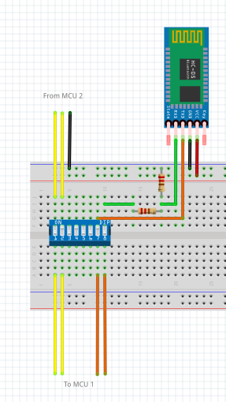

Figure 7.3.1

Figure 7.3.2

### Bluetooth interface description

A detailed description of the input

The HC-05 received char values over the 2.4 GHz bandwidth bluetooth connection to the Arduino Application and outputs the value by USART communication to MCU 1.

### Bluetooth module complications

The bluetooth module must have its TX and RX pins disconnected anytime we program MCU 1. If this is not done the Arduino will fail to program.

## Module 4: MCU 2

MCU 2 controls the relay for the pyrography pen, LCD, and read temperature values from the thermistor. MCU 2 uses Arduino’s custom C language to display important information to the user and ensure that an automated print is not started until the pen is at an appropriate temperature.

The LCD, some display screens, print percentage display screen, and thermistor were wired and coded by Dineth. Chris coded temperature display, print percentage communication data values, and the remaining display screens. Figure 7.4.1 is the Arduino Uno schematic and Figure 7.4.2 is the pin connection.

Figure 7.4.1

Figure 7.4.2

### Processing narrative for MCU 2

MCU 2 will receive USART input from MCU 1 and display the appropriate information on the screen. When the system is calibrating it begins heating the pen to prep it for the automated or manual drawing. Since manual drawing is meant to have full user control, they can begin drawing immediately after calibration completes regardless of temperature. For automated image drawing MCU 2 will not allow the MCU 1 to begin drawing until the pen has reached over 90ºF however it will con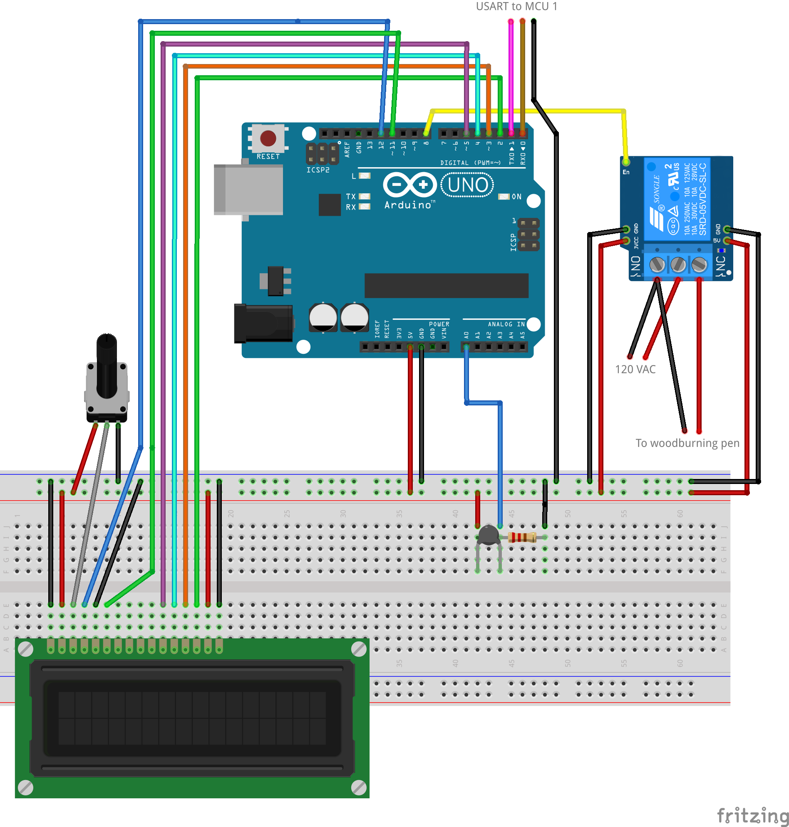tinue to display the temperature until the user determines the temperature to be appropriate.

### MCU 2 interface description

MCU 2 receives input from MCU 1 via USART and the thermistor. The outputs are to MCU 1 via USART and the LCD screen.

### MCU 2 processing details

For the processing of the USART communication we used values ranging from 1-27 and 150-250 for the print completion. For the temperature it monitors the room average when the system starts and then uses the difference to tell what the current temperature is.

## Module 5: Endstop System

The endstop system is in place to prevent overshooting the guide rails and for calibration of the system. There are 7 ends tops in place for x-max, x-min, y-max, y-min, z-max, z-min, and z-calibration. Figure 7.5.1 shows the endstop component schematic.

Figure 7.5.1

### Endstop interface description

MCU 1 receives the endstop’s output and interprets the location of the platform or z-axis position. The endstops then disables movement in that direction.

## Module 6: Motor Driver and Stepper Motors

Motor driver takes the input from MCU 1 for direction and step and converts it into the stepper motor movement pattern at the proper power to move the motor. Figure 7.4.1 show the stepper motor driver schematic with a stepper motor attached.

Figure 7.4.1

### Processing narrative for Motor Driver and Stepper Motors

The motor driver receives a direction and step PWM signal and then creates the next step pattern for the motor to move. The pattern is a repeating array in the order or reverse order of A, AB, B, BC, C, CD, D, AD and loops from there. Each one of these will activate a set of teeth on the motor and cause the motor to rotate to the closest next magnetized teeth.

### Motor Driver and Stepper Motors interface description

The motor driver inputs and outputs are connected through the RAMPs 1.4 motor driver shield. The inputs draw from MCU 1 and the power adapter. The outputs are then connected from the RAMPs 1.4 board to the stepper motors.

## Module 7: Relay Module

The relay module enables the pyrography pens voltage digitally. See figure 7.4.2 for the connectivity of the relay to MCU 2. Figure 7.7.1 shows the schematic of the relay



Figure 7.7.1

### Processing narrative for Relay Module

The relay will receive a binary 1 or 0 (5 VDC or 0 VDC) from MCU 2 and then close the 120 VAC circuit for the pyrography pen when its input is high and open when the input is low. Low is the resting value of the relay by default.

### Relay Module interface description

The relay is connected for its enable pins to MCU 2. The pyrography pen is connected to the relay’s main output terminal and the input terminal is connected to 120 VAC standard Edison wall connection.

## Module 8: Pyrography Pen

The pyrography pen when enabled heats a metal tip to temperatures up to 400ºF for pyrography. Figure 7.8.1 shows the pyrography pen schematic.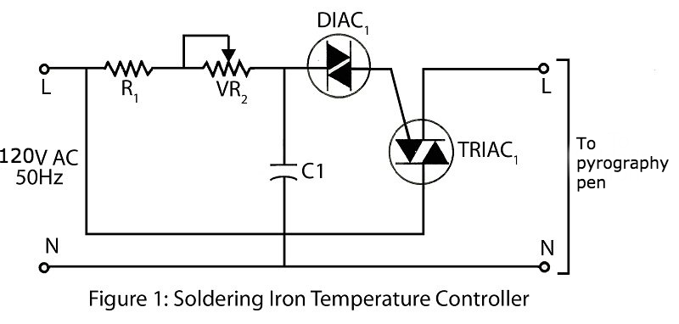

Figure 7.8.1

### Relay Module interface description

The pyrography pen is connected to the relay module and is passed power from a standard 120 VAC Edison outlet.

## Module 9: LCD Module

The LCD module is a 16x2 liquid crystal display implemented as a way to relay useful information from the system to the user. Figure 7.9.1 is the LCD schematic.

Figure 7.9.1

### Processing narrative for LCD Module

We used the Arduino liquid crystal library to allow for the writing of data to the screen. Therefore the lowest level of processing we experienced was that we were able to write up to 32 characters to the screen by passing in either variables, characters, or strings. The LCD would then serially wipe and read the new data and display it on the screen.

### LCD Module interface description

The LCD is connected to MCU 2 and has two separate connections to the 5V line and common ground for enabling the LCD and powering the backlight.

# * Technical Problem Solving

Document all the technical difficulties you encountered

## * The X Problem (change X to a description of your problem, e.g., Bluetooth Interface Problem, the Line Following Problem)

Describe the problem, who contributed to the identification of the problem

## * Solving the X Problem (change X to a description of your problem, e.g., Bluetooth Interface Problem)

Describe the approaches you used to solve problem, the technical difficulties you overcome, what new skills or lessons you learned in the process and who contributed to solving the problem

If you were unable to solve the problem, still describe what you did and what you decided to do instead to avoid the problem

Repeat the above two subsections for each technical difficulty you encountered.

# User Interface Design

This section provides user interface design descriptions that directly support construction of user interface screens.

State clearly who is responsible for which module/task

## Application Control

Detail the common behavior that all screens will have. Common look and feel details such as menus, popup menus, toolbars, status bar, title bars, drag and drop mouse behavior should be described here. Conventions and standards used for designing/implementing the user interface are stated.

## User Interface Screens

Illustrate all major user interface screens and describe the behavior and state changes that the user will experience. All screen objects and actions are identified.

A screen transition diagram or table can optionally be created to illustrate the flow of control through the various screens.

This does not have to be actual screenshots since they have not been programmed. They can be powerpoint drawings or mockups created in Visual Basic or some other rapid GUI-building tool.

# * Test Plan

## Manual Control Test Design

We want our machine to be able to hand draw patterns onto a piece of paper.

**Tests and expected responses**

The test will be performed by:

Roles:

Dineth: Code uploading.

Steven: Joystick control.

Chris: Paper attaching.

1. MCU 1 is powered on with driver shield, motor driver, stepper motors, joystick, and buttons attached.

2. The platform will move a direction using the joystick.

3. A piece of paper will be taped to the platform.

4. Platform will be moved under the Z-axis

5. The Z-axis will be lowered onto the platform.

6. The joystick will be used to draw a pattern on the machine.

7. Test is considered positive when a hand controlled pattern is written on the piece of paper.

## Bug Tracking

1. Occasionally the joystick would begin uncontrollably towards the left and bottom portion of the print zone.
2. When lowering z-axis weight was considered heavier than usual.
3. Joystick will be offset if the machine powers on with the joystick ajar.

## Quality Control

2/7/2017 5:57 P.M.

1. All test cases were passed on the two successful trial ran.

## Identification of critical components

1. There must be a piece of paper on the platform
2. There must be a pen attached to the z axis

## Items Not Tested by the Experiments

1. No automated mode will be tested during this experiment.
2. No pyrography will be done at this moment.
3. USART communication will not be tested between MCU 1 and MCU 2

## Three Directional Motor Movement Test Design

This test will have all three motors rotate in predetermined directions considered to be X, Y, and Z directions.

**Tests and expected responses**

The test will be performed by:

Roles:

Dineth: Motor wiring and code uploading.

Steven: Joystick control.

Chris: Power monitoring and speed monitoring.

1. MCU 1 is powered on with driver shield, motor driver, stepper motors, joystick, and buttons attached.

2. The joystick will be pressed in a single direction each time.

3. If step 2 succeeds, attach zip ties to motors and repeat test. Monitor speed for each direction.

4. Test is successful if the three motors are spinning successfully in the theoretical correct directions.

## Bug Tracking

1. The motors will lose speed when spinning simultaneously.
2. Speed goes from:
   1. Fast speed with 1 simultaneous motor movements
   2. Medium speed with 2 simultaneous motor movements
   3. Slowest speed with 3 simultaneous motor movements

## Quality Control

2/7/2017 5:57 P.M.

1. All test cases were passed on the two successful trial ran.
2. Bugs were observed and noted for debugging.

## Identification of critical components

1. There must be a solid clear area for the motors to rotate.
2. There must be a zip tie for each of the motors.

## Items Not Tested by the Experiments

1. No automated mode will be tested during this experiment.
2. The motors torque strength.
3. No pyrography will be done at this moment.
4. No Assembled structure
5. USART communication will not be tested between MCU 1 and MCU 2

# * Test Report

Carry out the experiments designed in the section above to test your modules and prototype and present the results. Present the results of the experiments and provide an analysis of the experimental test data.

State clearly who is responsible for which test case

Each test must be run multiple times. When you find deviation from the expected results, you must take action to debug your design, then test it again. Report each test iteration below

## * Test 1

Person(s) performing the experiment

1. Test results, person performing the test
2. Comparison with expected results
3. Analysis of Test results
4. Corrective actions taken

Must be performed multiple times. Report the above for each iteration of the test.

## * Test i (one section for each test i = 2, …., n)

Person(s) performing the experiment

1. Test results, person performing the test
2. Comparison with expected results
3. Analysis of Test results
4. Corrective actions taken

Must be performed multiple times. Report the above for each iteration of the test.

# * Conclusion and Future Work

## * Conclusion

Present the conclusion of your project, state clearly whether the finished work meet the overall project goals and the quantitative technical design objectives. If not, just state what and how it failed and the TECHNICAL reasons why it failed and what you have learned.

State clearly who is responsible for achieving or missing which goals/objectives.

* Must complete for each team member: Describe what you learned from this project, both in terms of technical knowledge and skill, professional and personal growth.

Do NOT complain and give personal, non-technical reasons why it failed. You should talk to your advisors about these, but do not include them in a design document.

## Future Work

Expansion and Improvement; discuss the impact of this work and its possible expansion into perhaps a more promising design than what you had started. This is particularly important in order to address the marketability of your design. Or why this project merits another look by perhaps next year's students.

## * Acknowledgement

Be considerate and credit all those who have helped you in this project, especially credit the people who provided ideas or solutions.

# * References

List the references used in the design, including books, data sheets, technical documents, industry standard documents. References can be printed documents or online.

Use the IEEE Citation procedures and list in alphabetic order all your references based on their first, second, etc., authors, in a chronological order. You may include these references depending on each chapter or as a whole.

# * Appendices

Presents information that supplements the design specification, including:

**\* Appendix A:** Parts List

**\* Appendix B:** Equipment List

**\* Appendix C:** Software List (URL to online drive or SVN server, with sharing set to Public. Can omit this appendix if your project didn’t involving writing a program)

**Appendix D:** Special Resources

**Appendix E:** User's Manual - If your design requires instructions for future use, here is the place to put that information.

**Appendix F to Z:** Whatever Else You Wish To Add; for instance, here, you may include detailed solution methods or derivations, which you need for your future review of this report or whoever else is interested to pursue this study. Some side drawings and printouts that are of value to people who will continue this work should be given herein. Some information about the vendors and how to locate parts for similar projects must be included herein. In other words, information that is important about the overall construction of the project should be given herein.)